Test Case: tc002_SPX_Dev5_Crear_Requisicion_Spot_Con_FAD_Tipo_Cobro_CC
Step 1 - Enter username and password and click to button Enter : Credentials Entered
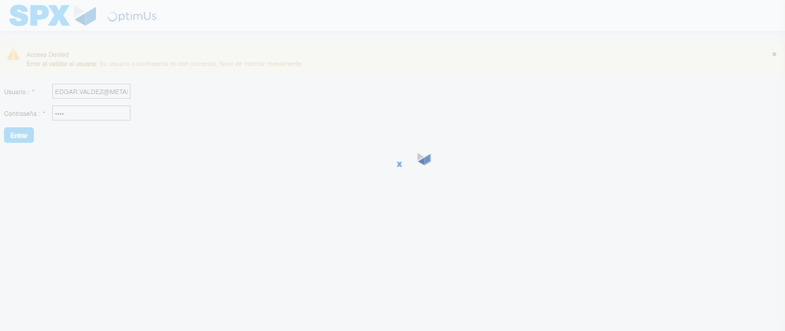Image file-name: QC_Testing-tc002_SPX_Dev5_Crear_Requisicion_Spot_Con_FAD_Tipo_Cobro_CC-1781656758476

Step 2 - Select to UEN and Access to Spot Buy Requisitions : UEN Correctly selected and Correct access
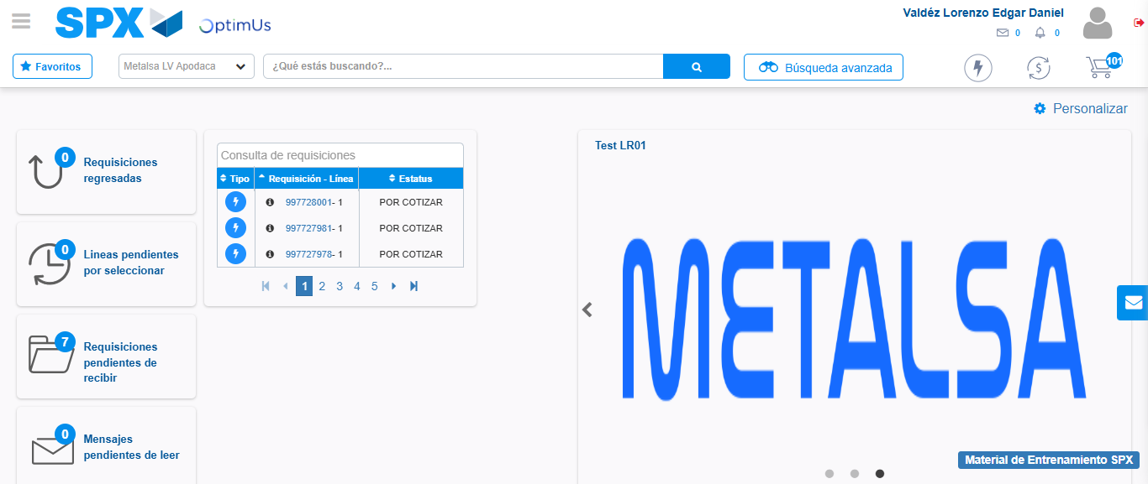Image file-name: QC_Testing-tc002_SPX_Dev5_Crear_Requisicion_Spot_Con_FAD_Tipo_Cobro_CC-1781656783913

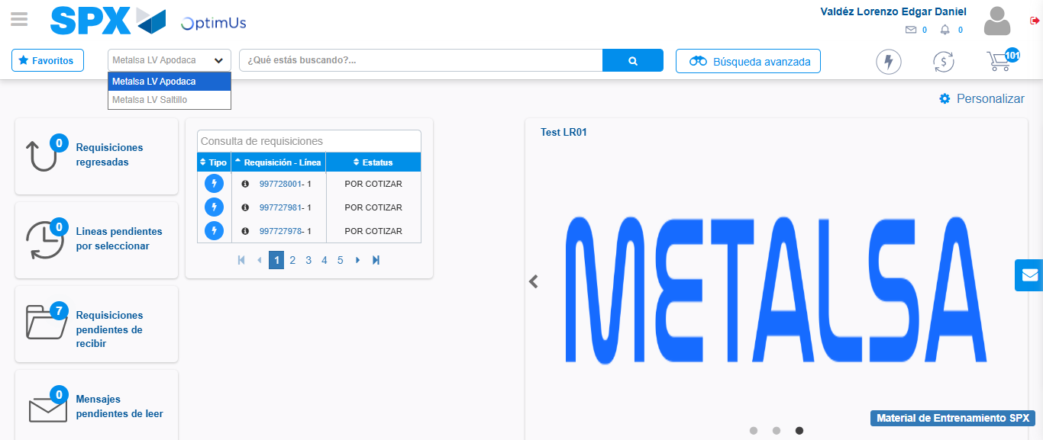Image file-name: QC_Testing-tc002_SPX_Dev5_Crear_Requisicion_Spot_Con_FAD_Tipo_Cobro_CC-1781656786513

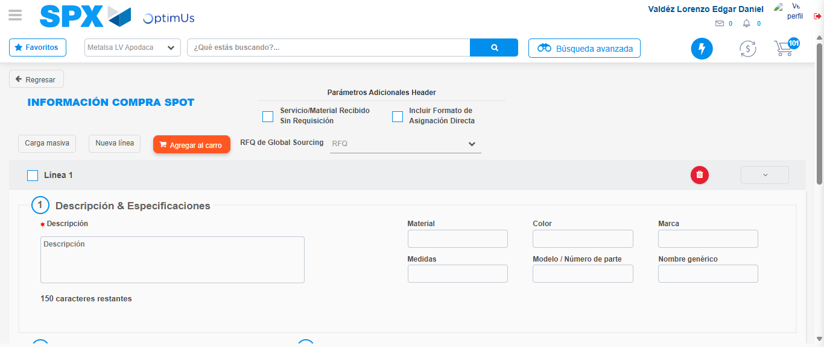Image file-name: QC_Testing-tc002_SPX_Dev5_Crear_Requisicion_Spot_Con_FAD_Tipo_Cobro_CC-1781656815174

Step 3 - Add FAD to Requisition: FAD Successfully Added
Image file-name: QC_Testing-tc002_SPX_Dev5_Crear_Requisicion_Spot_Con_FAD_Tipo_Cobro_CC-1781656815420

Image file-name: QC_Testing-tc002_SPX_Dev5_Crear_Requisicion_Spot_Con_FAD_Tipo_Cobro_CC-1781656815597

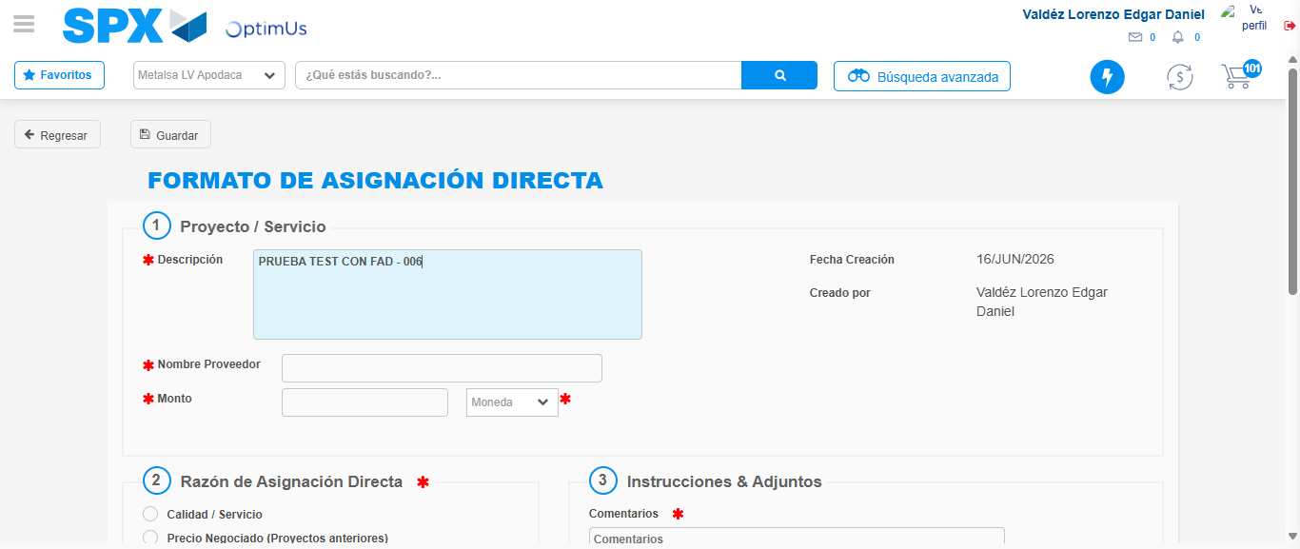Image file-name: QC_Testing-tc002_SPX_Dev5_Crear_Requisicion_Spot_Con_FAD_Tipo_Cobro_CC-1781656818292

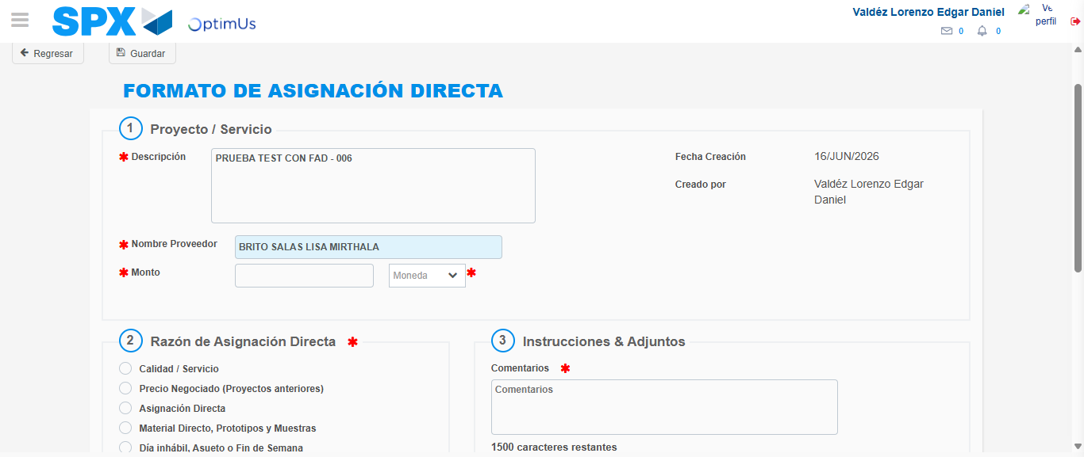Image file-name: QC_Testing-tc002_SPX_Dev5_Crear_Requisicion_Spot_Con_FAD_Tipo_Cobro_CC-1781656823415

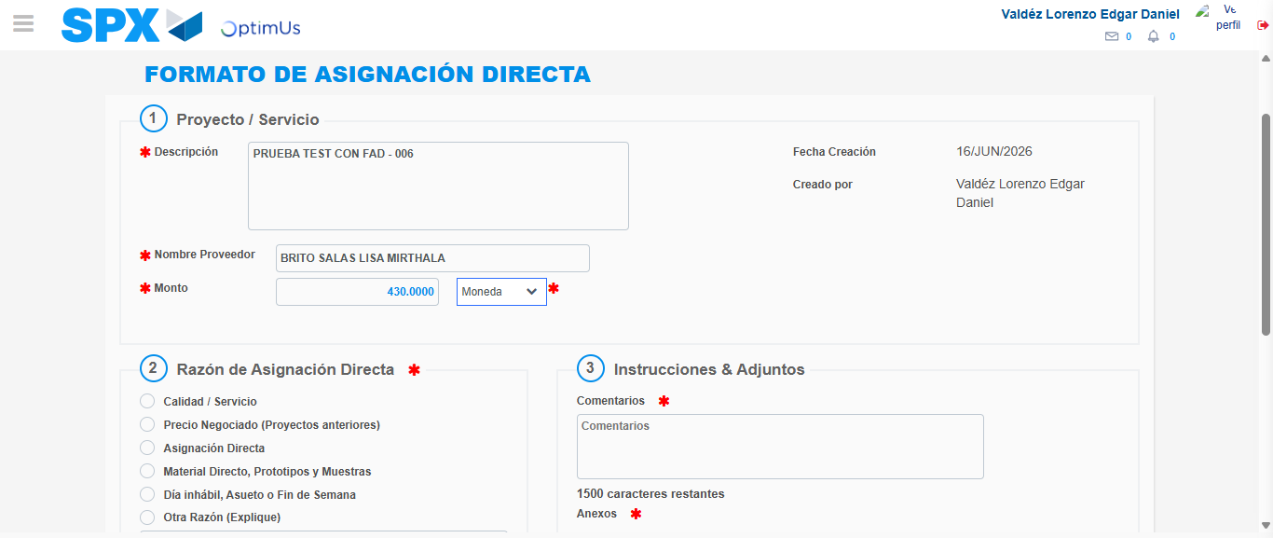Image file-name: QC_Testing-tc002_SPX_Dev5_Crear_Requisicion_Spot_Con_FAD_Tipo_Cobro_CC-1781656823844

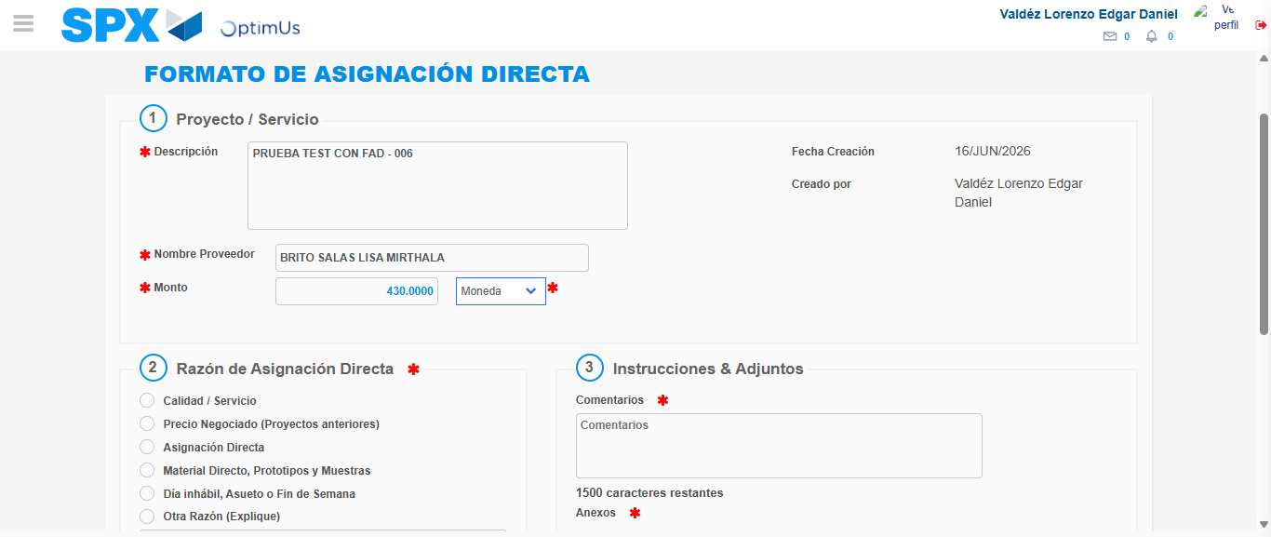Image file-name: QC_Testing-tc002_SPX_Dev5_Crear_Requisicion_Spot_Con_FAD_Tipo_Cobro_CC-1781656824038

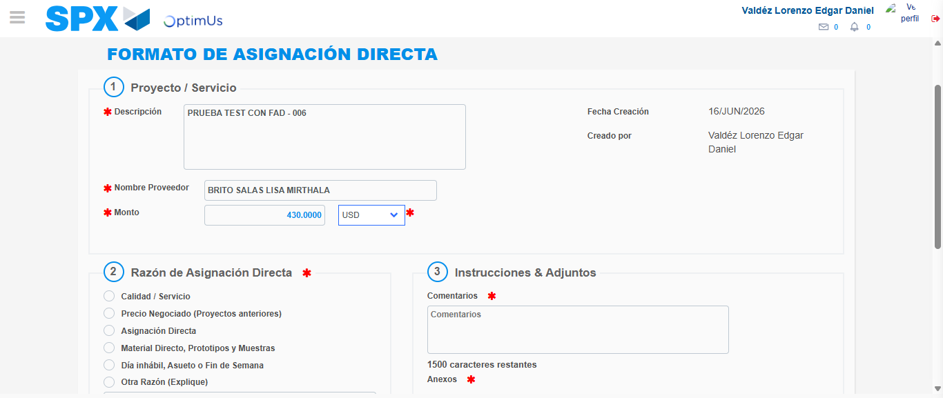Image file-name: QC_Testing-tc002_SPX_Dev5_Crear_Requisicion_Spot_Con_FAD_Tipo_Cobro_CC-1781656824438

Image file-name: QC_Testing-tc002_SPX_Dev5_Crear_Requisicion_Spot_Con_FAD_Tipo_Cobro_CC-1781656824618

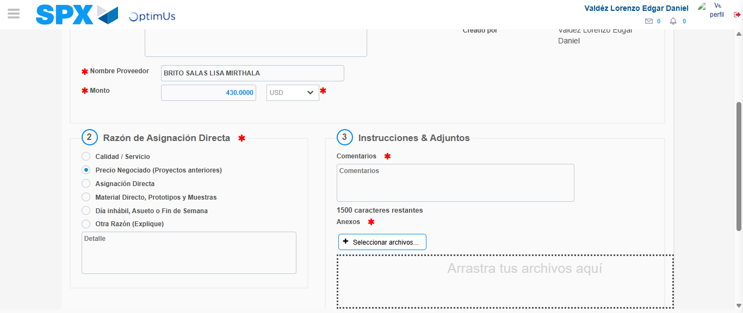Image file-name: QC_Testing-tc002_SPX_Dev5_Crear_Requisicion_Spot_Con_FAD_Tipo_Cobro_CC-1781656825503

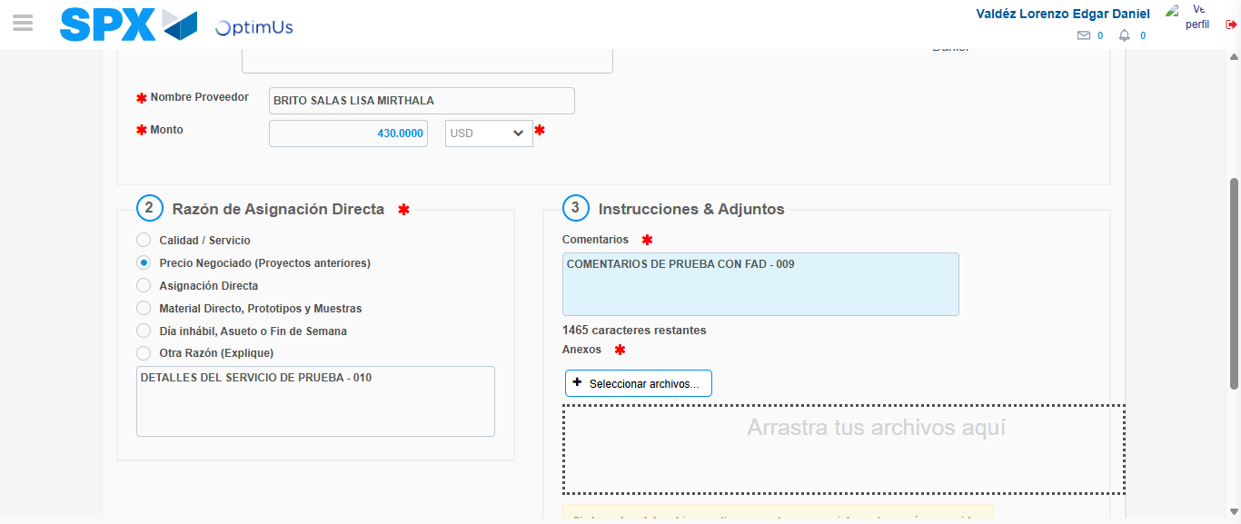Image file-name: QC_Testing-tc002_SPX_Dev5_Crear_Requisicion_Spot_Con_FAD_Tipo_Cobro_CC-1781656836383

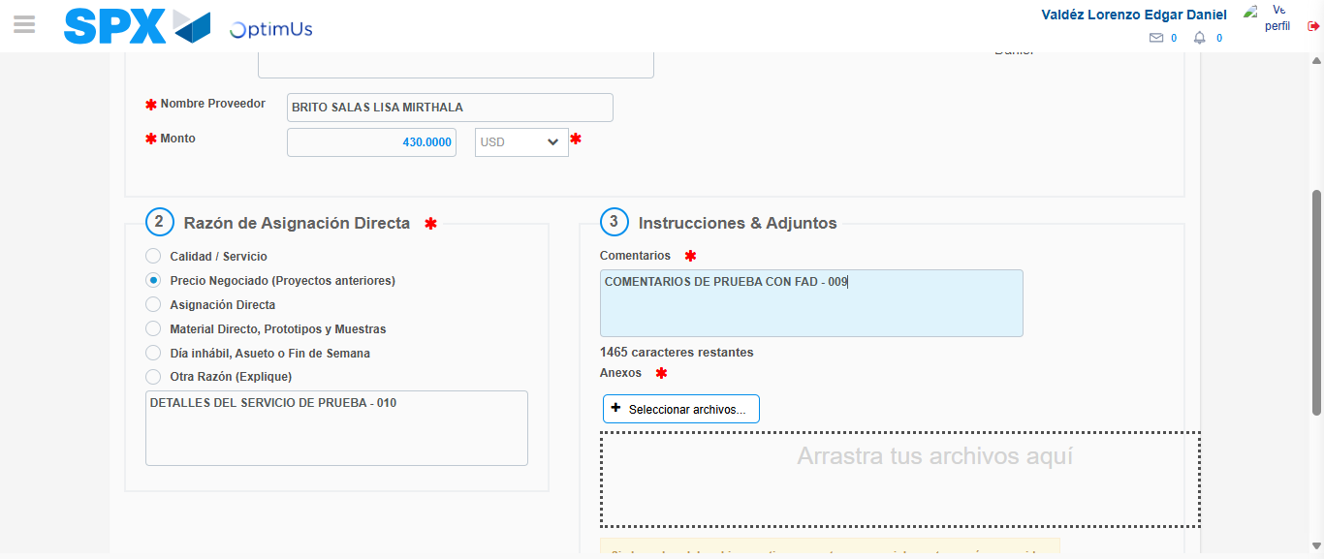Image file-name: QC_Testing-tc002_SPX_Dev5_Crear_Requisicion_Spot_Con_FAD_Tipo_Cobro_CC-1781656836952

Step 4 - Data Capture Spot Buy Requisition: Data captured correctly
Image file-name: QC_Testing-tc002_SPX_Dev5_Crear_Requisicion_Spot_Con_FAD_Tipo_Cobro_CC-1781656815420

Image file-name: QC_Testing-tc002_SPX_Dev5_Crear_Requisicion_Spot_Con_FAD_Tipo_Cobro_CC-1781656815597

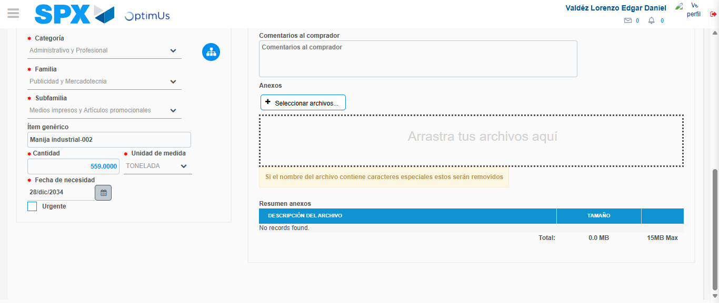Image file-name: QC_Testing-tc002_SPX_Dev5_Crear_Requisicion_Spot_Con_FAD_Tipo_Cobro_CC-1781656848732

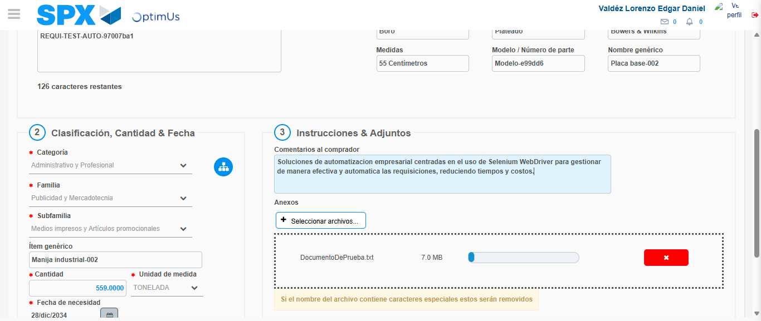Image file-name: QC_Testing-tc002_SPX_Dev5_Crear_Requisicion_Spot_Con_FAD_Tipo_Cobro_CC-1781656849481

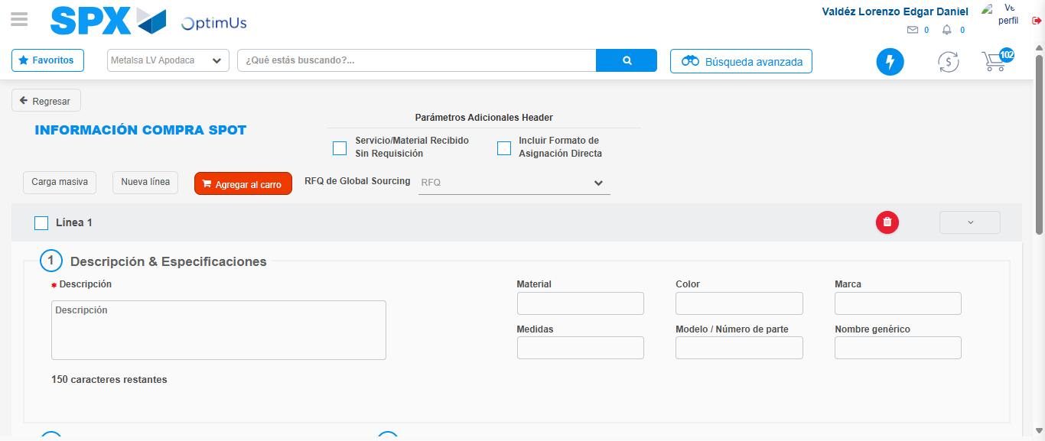Image file-name: QC_Testing-tc002_SPX_Dev5_Crear_Requisicion_Spot_Con_FAD_Tipo_Cobro_CC-1781656854492

Step 5 - Select to Requisition: Requisition Correctly selected
Image file-name: QC_Testing-tc002_SPX_Dev5_Crear_Requisicion_Spot_Con_FAD_Tipo_Cobro_CC-1781656854668

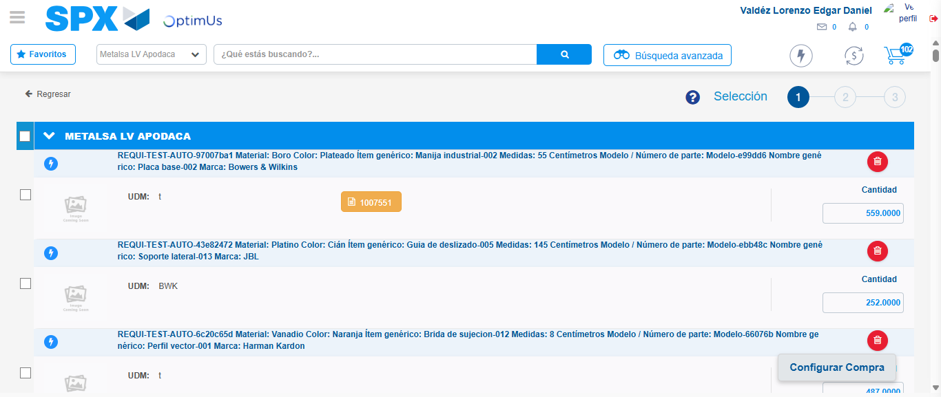Image file-name: QC_Testing-tc002_SPX_Dev5_Crear_Requisicion_Spot_Con_FAD_Tipo_Cobro_CC-1781656863989

Image file-name: QC_Testing-tc002_SPX_Dev5_Crear_Requisicion_Spot_Con_FAD_Tipo_Cobro_CC-1781656864254

Image file-name: QC_Testing-tc002_SPX_Dev5_Crear_Requisicion_Spot_Con_FAD_Tipo_Cobro_CC-1781656864473

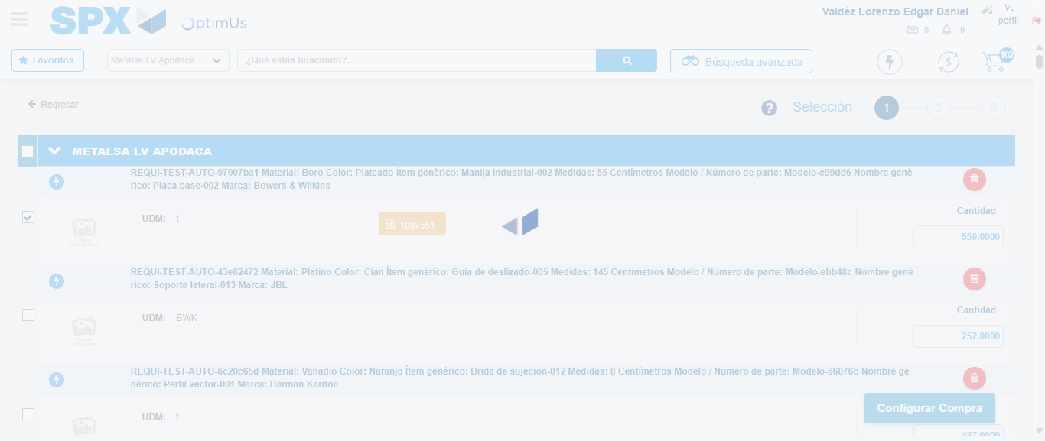Image file-name: QC_Testing-tc002_SPX_Dev5_Crear_Requisicion_Spot_Con_FAD_Tipo_Cobro_CC-1781656865363

Step 6 - Select Type Account For Requisition: Type Account Correctly selected
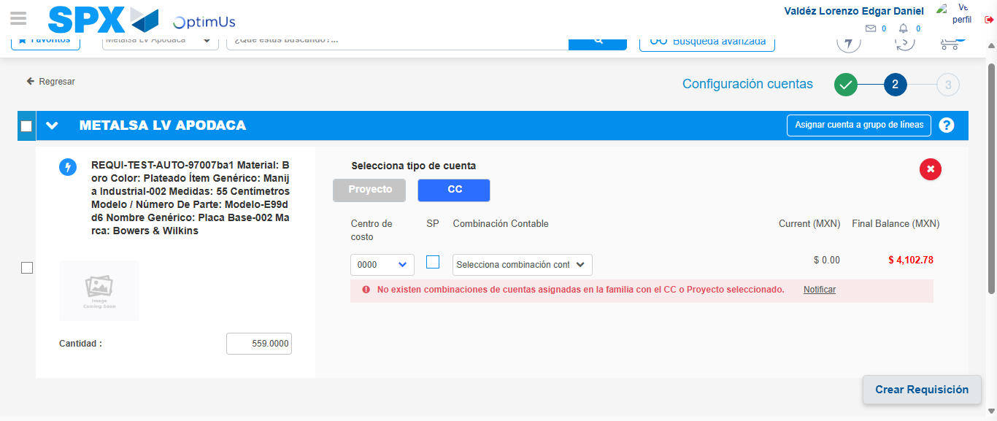Image file-name: QC_Testing-tc002_SPX_Dev5_Crear_Requisicion_Spot_Con_FAD_Tipo_Cobro_CC-1781656891923

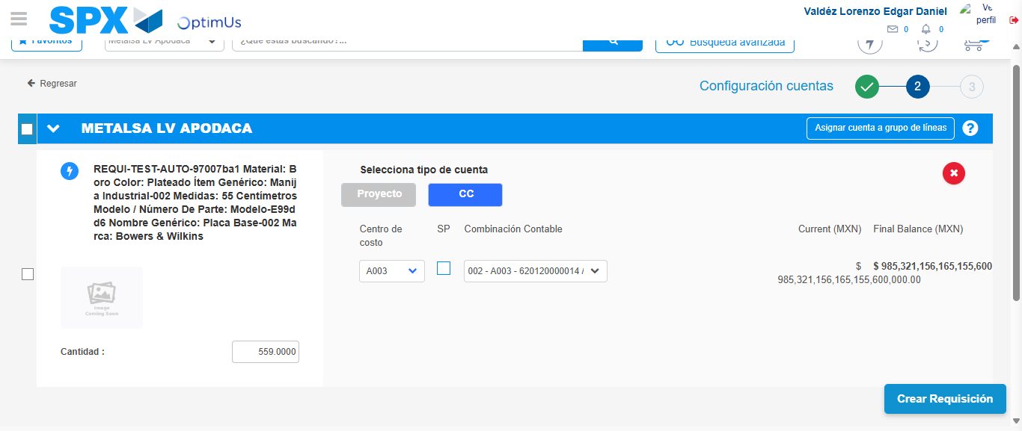Image file-name: QC_Testing-tc002_SPX_Dev5_Crear_Requisicion_Spot_Con_FAD_Tipo_Cobro_CC-1781656901392

Image file-name: QC_Testing-tc002_SPX_Dev5_Crear_Requisicion_Spot_Con_FAD_Tipo_Cobro_CC-1781656901576

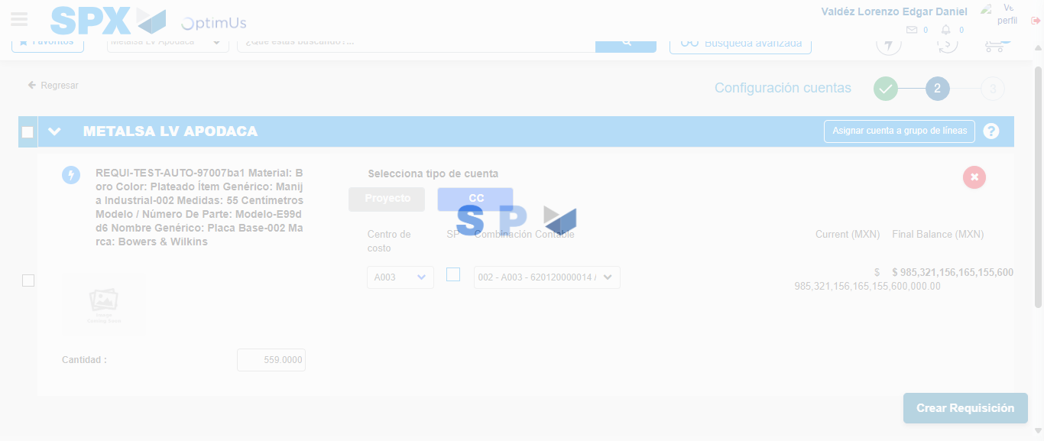Image file-name: QC_Testing-tc002_SPX_Dev5_Crear_Requisicion_Spot_Con_FAD_Tipo_Cobro_CC-1781656901910

Step 7 - Accept to Requisition: Requisition Accepted
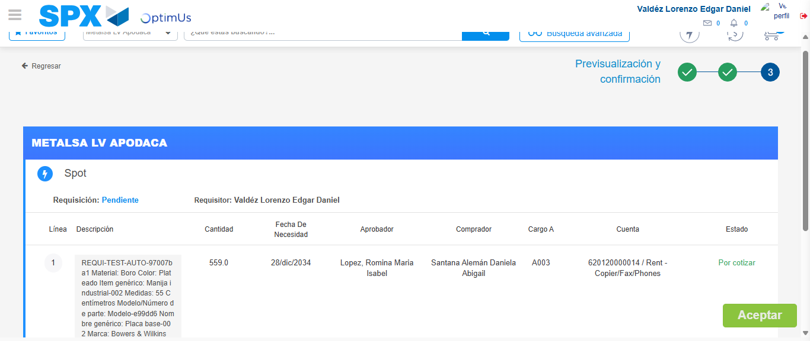Image file-name: QC_Testing-tc002_SPX_Dev5_Crear_Requisicion_Spot_Con_FAD_Tipo_Cobro_CC-1781656902698

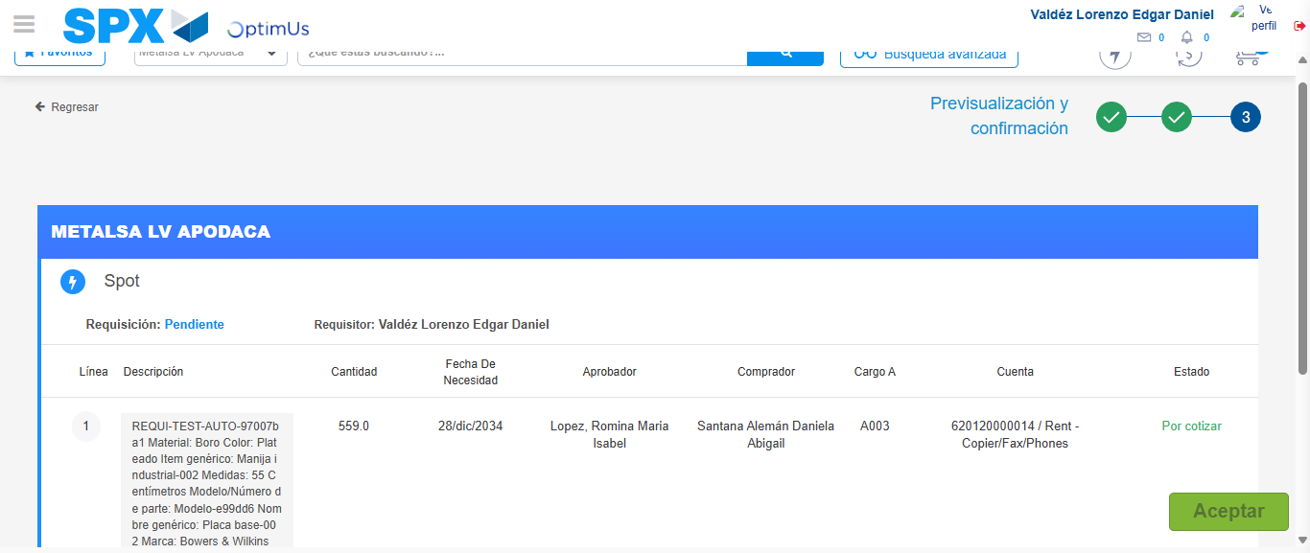Image file-name: QC_Testing-tc002_SPX_Dev5_Crear_Requisicion_Spot_Con_FAD_Tipo_Cobro_CC-1781656902904

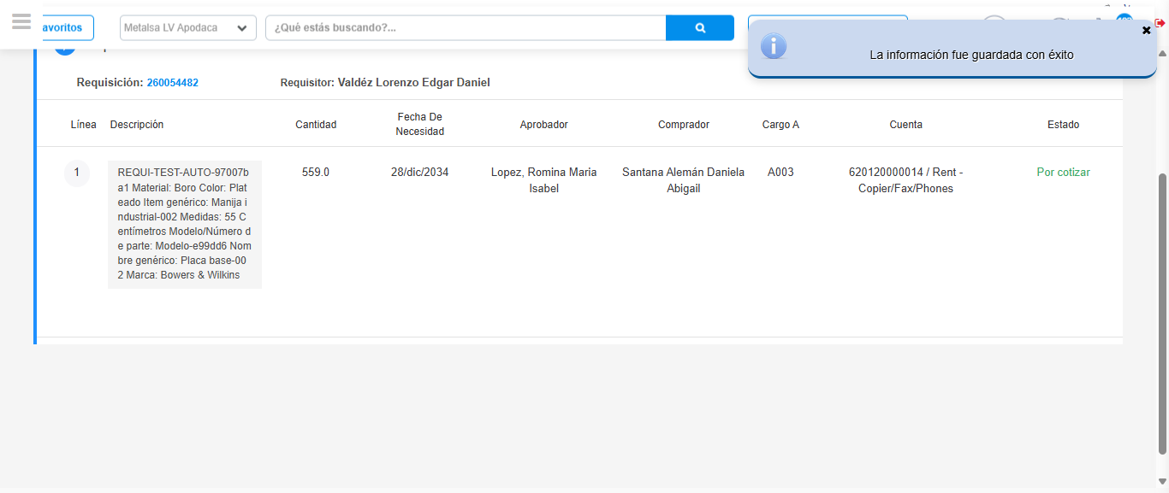Image file-name: QC_Testing-tc002_SPX_Dev5_Crear_Requisicion_Spot_Con_FAD_Tipo_Cobro_CC-1781656905994

Step 8 - Return to Main Page SPX : Return to Main Page SPX
Image file-name: QC_Testing-tc002_SPX_Dev5_Crear_Requisicion_Spot_Con_FAD_Tipo_Cobro_CC-1781656783913

Image file-name: QC_Testing-tc002_SPX_Dev5_Crear_Requisicion_Spot_Con_FAD_Tipo_Cobro_CC-1781656786513

Image file-name: QC_Testing-tc002_SPX_Dev5_Crear_Requisicion_Spot_Con_FAD_Tipo_Cobro_CC-1781656815174

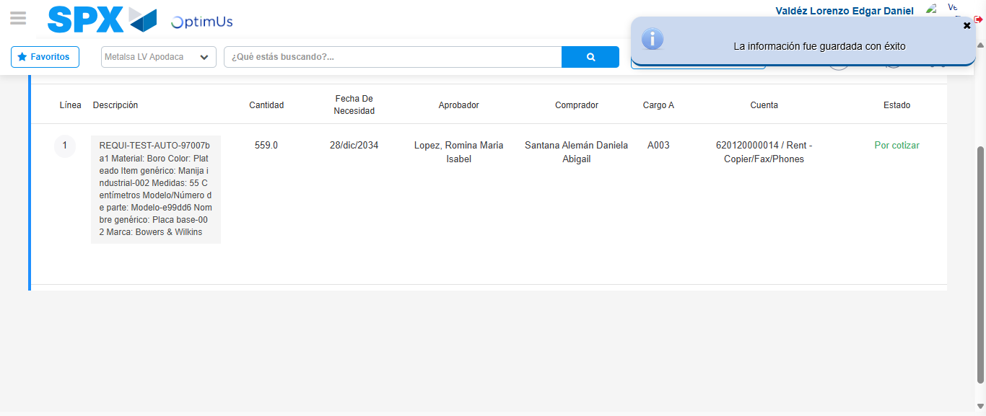Image file-name: QC_Testing-tc002_SPX_Dev5_Crear_Requisicion_Spot_Con_FAD_Tipo_Cobro_CC-1781656908192

Image file-name: QC_Testing-tc002_SPX_Dev5_Crear_Requisicion_Spot_Con_FAD_Tipo_Cobro_CC-1781656908358

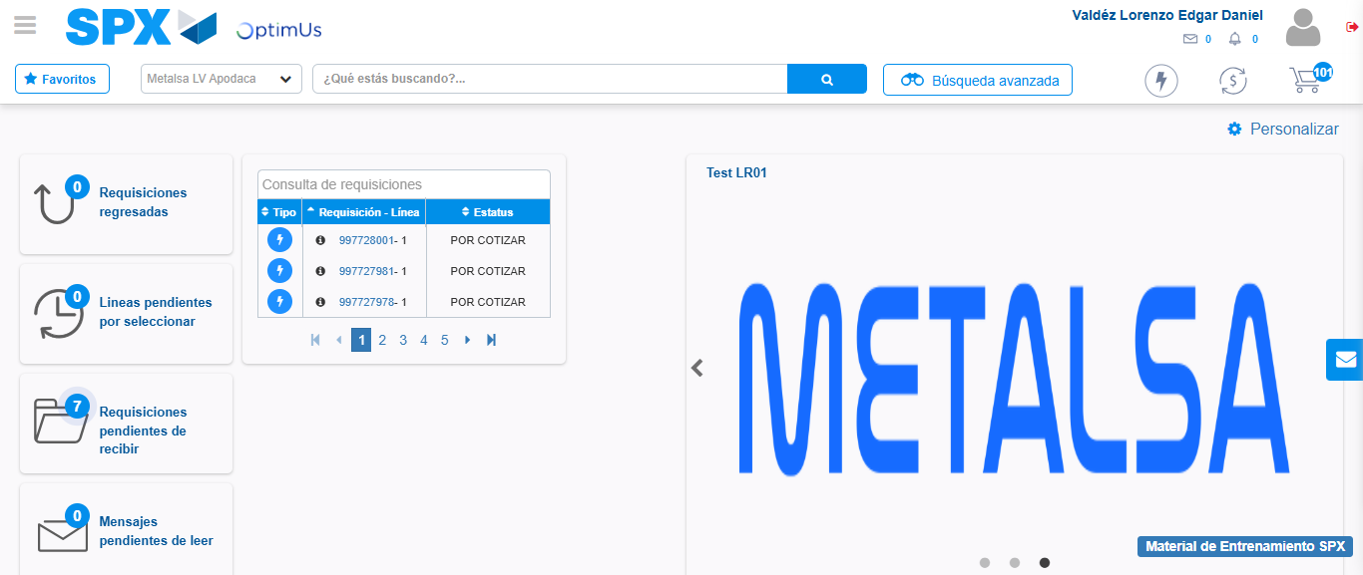Image file-name: QC_Testing-tc002_SPX_Dev5_Crear_Requisicion_Spot_Con_FAD_Tipo_Cobro_CC-1781656929557

Step 9 - Log Out : Log Out SPX
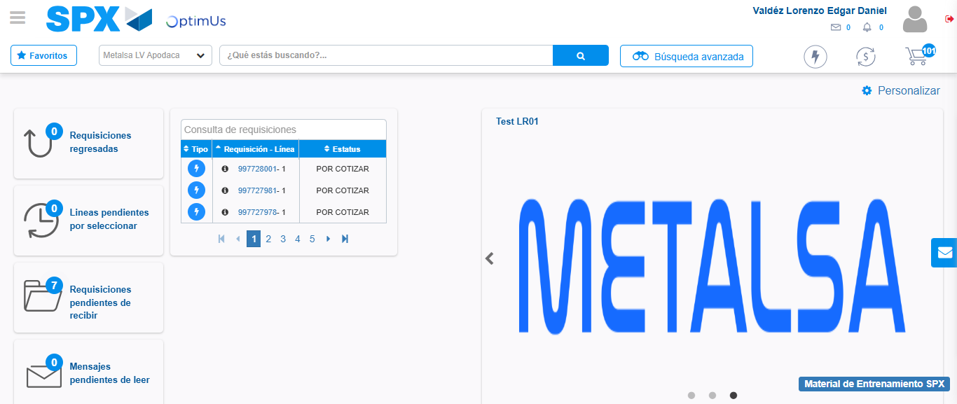Image file-name: QC_Testing-tc002_SPX_Dev5_Crear_Requisicion_Spot_Con_FAD_Tipo_Cobro_CC-1781656929814

